Program Final examination on discipline «Proteomic technologies

Numerous methods are available to study proteins, sets of proteins, or the whole proteome. In fact, proteins are often studied indirectly, e.g. using computational methods and analyses of genomes.

The proteome term is applied to several different types of biological systems. A cellular proteome is the collection of proteins found in a particular cell type under a particular set of environmental conditions such as exposure to hormone stimulation. It can also be useful to consider an organism's complete proteome, which can be conceptualized as the complete set of proteins from all of the various cellular proteomes. This is very roughly the protein equivalent of the genome. The term "proteome" has also been used to refer to the collection of proteins in certain sub-cellular biological systems. For example, all of the proteins in a virus can be called a viral proteome.

Module 1 High-throughput proteomic technologies. Current research methodologies
Study in Proteins.
Practical significance of study in Proteins
Study and methodology of three-dimensional structure (3 D ) of proteins ,
The principle of NMR spectroscopy. Using NMR spectroscopy in study of proteins
The procedure for NMR solution structure determination
Methods of X-ray crystallography
Procedure using of X-ray crystallography in study of proteins
Mechanisms of phosphorylation
Protein kinases
Method of detection
Major research methods in study of protein post-translational modification (PTM)
Significance of phosphorylation in signal transduction cascades and methods to determine them
Using of immonodetection in protein phosphorylation
Using of immunochemistry in study of proteins
The mass spectrometry methods in study of proteins
In vitro analysis of protein phosphorylation
Quantitative Mass spectrometry
Matrix-assisted laser desorption ionization in proteomic analysis
Electrospray ionization in proteomic analysis
Two-dimensional gel electrophoresis. Using. Stages.

Module 2 Technologies used for post-translational modifications studies
Protein post-translational modification (PTM)
Protein methylation as protein post-translational modification
Methods in study of protein methylation
Phosphoprotein enrichment methodology
Significance of acetylation of proteins
Protein acetylation as post-translational regulatory mechanism
Strategies for the detection of acetylated proteins.
Methods of confirmation of the presence of acetylation in proteins (radioactive detection or immunodetection techniques)
Mass spectrometry as method to confirm the identity of the protein and to reveal the number of acetylation sites.
In vitro method to separate acetylated proteins 1D, one-dimensional/ 2D, two-dimensional electrophoresis
In vitro method to separate acetylated proteins using chromatography- based method
Immunodetection method in study of acetylated proteins using acetyl-lycine specific antibodies
Method of determination of intact molecular weight of acetylated proteins using mass spectrometry
Western blotting in study of acetylated proteins
Immunohistochemical analysis in study of acetylated proteins
Mass spectrometric analysis of acetylated proteins
Proteins glycosylation, a post-translational modification (PTM).
Functions of proteins glycosylation
Types of protein glycosylation and methods of their determination
Methods to detect and analyze glycoproteins
Glycan staining or labeling in study of glycosalated proteins
Method of glycoprotein purification or enrichment
Principles of glycoproteome and glycome analysis by mass spectrometry
The general approach of quantitative proteomics.
The use of stable isotopes in quantitative proteomics.
SILAC, stable isotope labeling with amino acids in cell culture method
Origin and function of ubiquitin-like protein conjugation
Stable isotope labeling in mass spectrometry-based quantitative proteomics
The use of stable isotopes in proteomics (Isotope-coded affinity tags (ICATTM) methodology).
Enzymatic labeling in quantitative proteomics
The AQUATM (Absolute quantification in quantitative proteomics
Origin and function of ubiquitin-like protein conjugation
Ubiquitination is an enzymatic, protein post-translational modification (PTM)
Activation of system ubiquitin
Function and variety of ubiquitin modifications
Technology to determine ubiquitylation of a protein
Multiple procedures to determine a ubiquitylated protein
Methods to investigate the factors that specifically target the substrate for ubiquitylation
Methods to determine the site of ubiquitin conjugation.
The methods to determine ubiquitylation of a protein:
Method to determine a ubiquitylated protein in vivo
Method to determine a ubiquitylated protein in vitro
Technology to determine the site of ubiquitylation (on a lysine residue or the N‐terminal ‐amino group).
Western blot analysis to identify the ubiquitylated species.
Method to preserve the ubiquitylated forms before analysis of them (using an inhibitor of the proteasome for cells)
Western blot analysis in proteomics technology
Affinite chromatography in proteomics technology
The use of high performance liquid chromatography HLPC in study of proteins
Protein lipidation stages
The principles of high performance liquid chromatography HLPC
Regulation of protein trafficking by palmitoylation
Regulation by S-Nitrosylation of protein post-translational modification
The methylation of proteins, its significance and main approaches to study
Methods of determination of arginine-methylated protein complexes
MALDI-ToF peptide mass fingerprinting spectra
The principles of CNE, clear native electrophoresis
Methods in study of protein-protein inter- interaction ( two-hybrid system)
Technology in study of protein lipidation
The principles of BNE, blue-native electrophoresis
Module 3 Protein detection with antibodies (immunoassays) The enzyme-linked immunosorbent assay (ELISA) has been used for decades to detect and quantitatively measure proteins in samples. The Western blot can be used for detection and quantification of individual proteins, where in an initial step a complex protein mixture is separated using SDS-PAGE and then the protein of interest is identified using an antibody.
Hybrid technologies Examples of these methods are the MSIA (mass spectrometric immunoassay) developed by Randall Nelson in 1995 and the SISCAPA (Stable Isotope Standard Capture with Anti-Peptide Antibodies) method, introduced by Leigh Anderson in 2004.

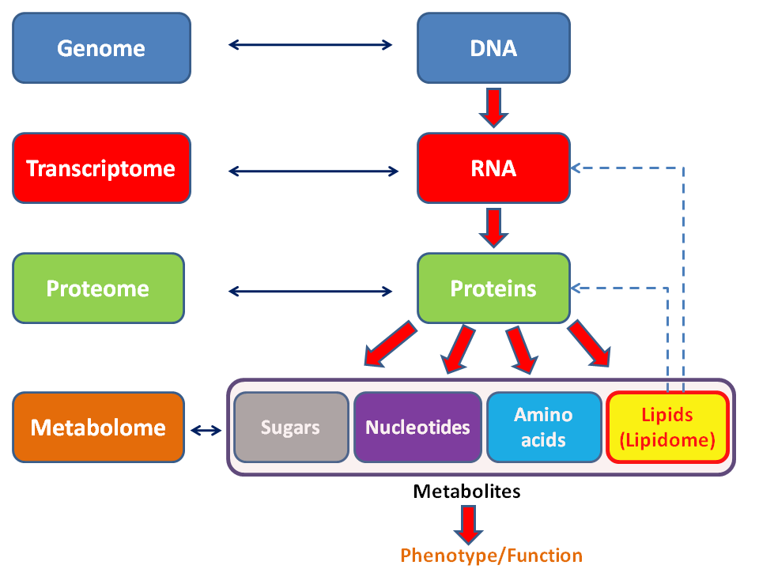

General schema showing the relationships of the genome, transcriptome, proteome, and metabolome (lipidome).

The teacher,
prof. S.S. Kenzhebayeva

